A mandala is a sacred symbol of Buddhist culture. Mandalas use radial symmetry to create geometric designs that are said to represent the universe. In traditional Buddhist art, a mandala is based on scriptures and designed by monks after many years of study and memorization. In Sanskrit (one of the oldest known languages in the world) mandala means both circle and center, implying that it represents both the visible world around us (the circle the whole world) and the invisible one deep inside our minds and bodies (the center healing circle). From Native American and Tibetan sand-paintings to Gothic rose windows and Hindu Yantras, mandalas are used as symbols for meditation, protection and healing. Some feel the process of creating a mandala is calming and even healing. It creates feelings of unity, wholeness, and peace.

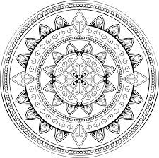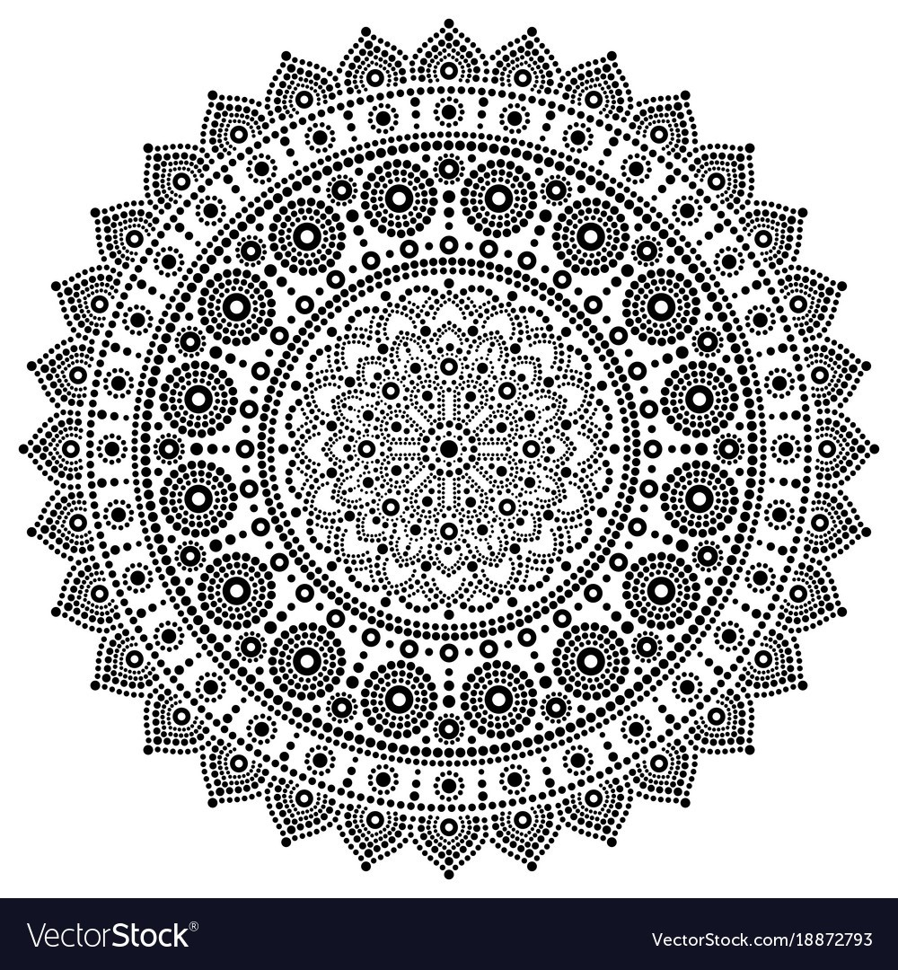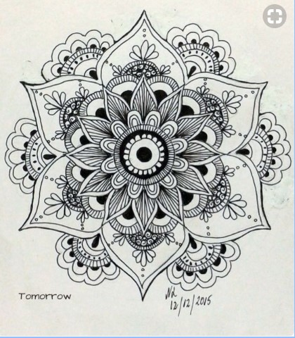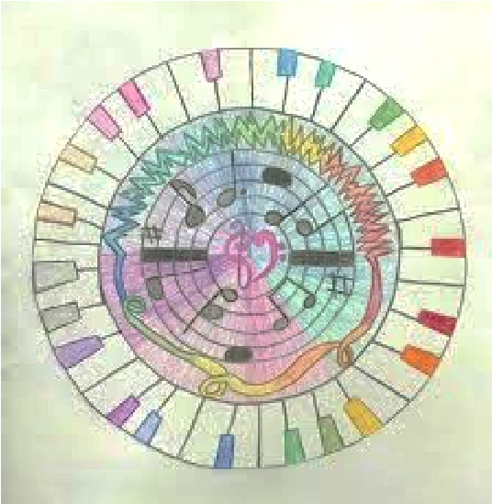

Student example

Radial symmetry art is when the artist uses objects, patterns, and

designs repeated in a circular design. Look at the student example above. The student used music as inspiration for their design. In the other examples simple shapes and lines are used to create some complex looking designs.

Creating a mandala is really quite easy and you can make it as simple or complex as you like. You can start by putting a small dot or circle in the center of a blank page. Then, just add lines, shapes, and/or patterns that repeat in a circle around the center.

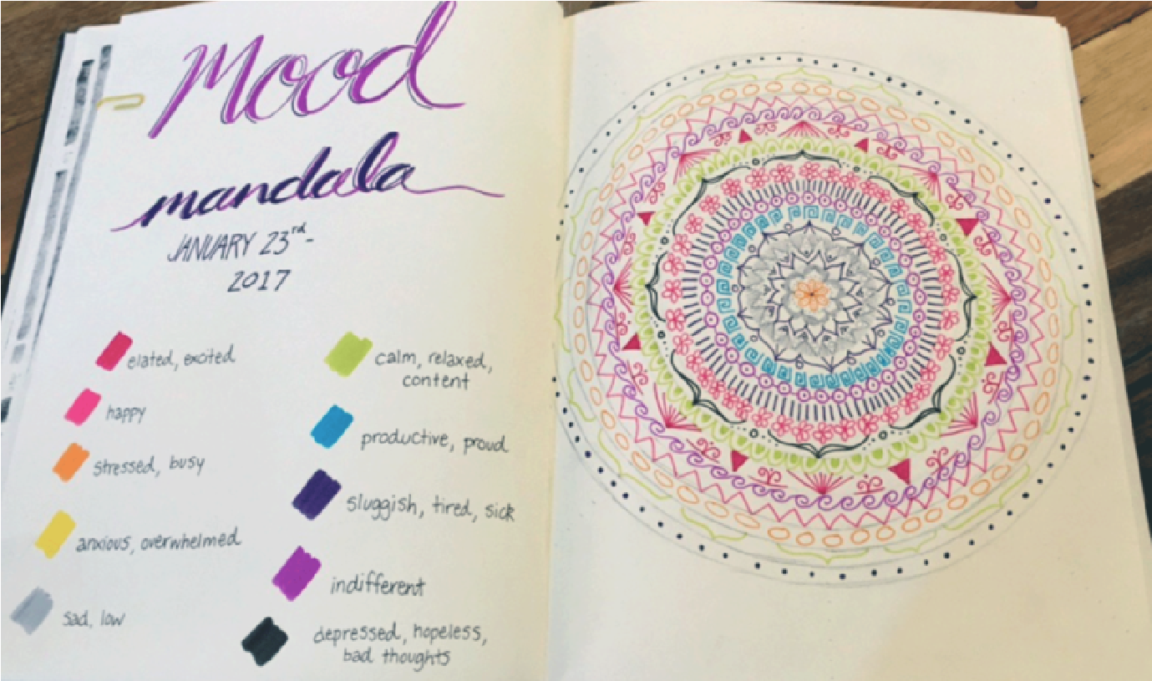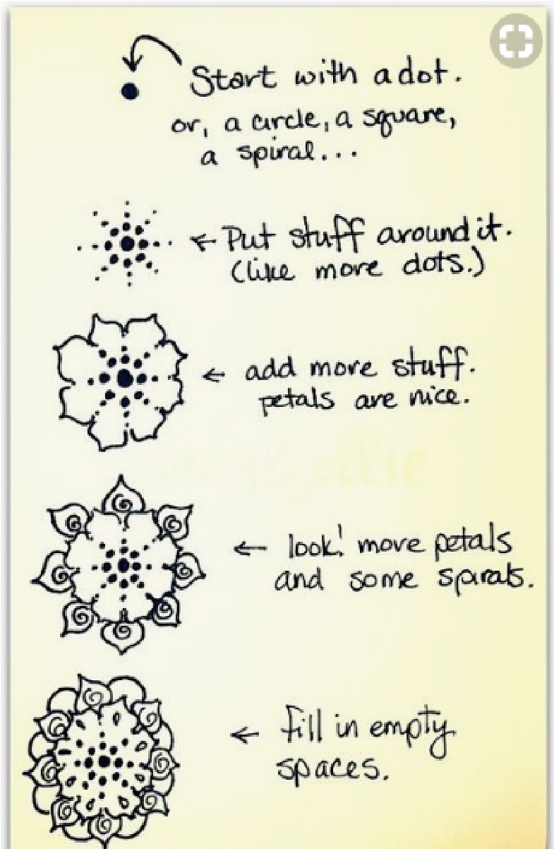

I

f

you have colored pencils or markers at

home you

can create a Mood Mandala! First you create a key

with each color representing a different mood. Each

day you can add a circular design in the color that

reflects how you are feeling that day.